Snowflake Data Loading, Continuous Ingestion & Processing Lab

LAB OBJECTIVE
You will:
- Load data using stages + COPY INTO
- Implement continuous ingestion using Snowpipe
- Work with structured & semi-structured data
- Use Streams & Tasks for CDC
- Perform advanced SQL transformations

PREREQUISITES
- Snowflake account (trial)
- Access to Snowsight
- Sample dataset (CSV + JSON)
- (Optional) AWS S3 / Azure Blob for external stage

ARCHITECTURE OVERVIEW
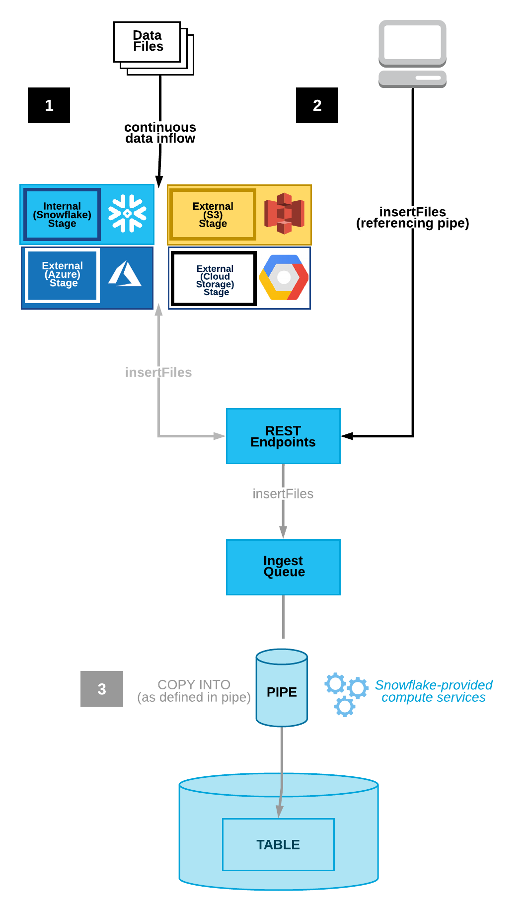
DATA LOADING FUNDAMENTALS

LAB 4.1 — Create File Format
CREATE FILE FORMAT csv_format
TYPE = 'CSV'
FIELD_OPTIONALLY_ENCLOSED_BY = '"'
SKIP_HEADER = 1;

LAB 4.2 — Create Internal Stage
CREATE STAGE internal_stage
FILE_FORMAT = csv_format;

LAB 4.3 — Upload File (Snowsight UI)
Steps:
- Go to Data → Databases
- Select stage
- Click Upload
- Upload CSV file

LAB 4.4 — Create Target Table
CREATE TABLE customers (
customer_id INT,
name STRING,
city STRING
);

LAB 4.5 — Load Data using COPY INTO
COPY INTO customers
FROM @internal_stage
FILE_FORMAT = (FORMAT_NAME = csv_format);

LAB 4.6 — Validate Data
SELECT * FROM customers;

LAB 4.7 — External Stage (S3 / Azure / GCS)
CREATE STAGE ext_stage
URL = 's3://your-bucket/path/'
CREDENTIALS = (AWS_KEY_ID='xxx' AWS_SECRET_KEY='xxx')
FILE_FORMAT = csv_format;

LAB 4.8 — Load JSON (Semi-Structured)
CREATE TABLE json_data (data VARIANT);
COPY INTO json_data
FROM @internal_stage
FILE_FORMAT = (TYPE = 'JSON');

LAB 4.9 — Query JSON Data
SELECT data:name, data:age FROM json_data;

LAB 4.10 — SnowSQL CLI
Steps:
- Install SnowSQL
- Connect:
snowsql -a <account> -u <user>
- Run query:
SELECT CURRENT_VERSION();

CONTINUOUS & ADVANCED LOADING

LAB 5.1 — COPY Options

PURGE
COPY INTO customers
FROM @internal_stage
PURGE = TRUE;

ON_ERROR
COPY INTO customers
FROM @internal_stage
ON_ERROR = 'CONTINUE';

FORCE
COPY INTO customers
FROM @internal_stage
FORCE = TRUE;

MATCH_BY_COLUMN_NAME
COPY INTO customers
FROM @internal_stage
MATCH_BY_COLUMN_NAME = CASE_INSENSITIVE;

LAB 5.2 — Snowpipe Setup

Step 1: Create Pipe
CREATE PIPE my_pipe
AUTO_INGEST = TRUE
AS
COPY INTO customers
FROM @ext_stage;

Step 2: Configure Event Notification
- S3 → SNS → SQS → Snowpipe

Step 3: Test
- Upload file to S3
- Data auto loads

LAB 5.3 — Unload Data
COPY INTO @internal_stage/export/
FROM customers
FILE_FORMAT = (TYPE = 'CSV');

LAB 5.4 — Data Loading Best Practices
- Use compressed files (gzip)
- Use large file sizes (100MB+)
- Avoid many small files
- Monitor load history

MODULE 6 LAB — DATA PROCESSING & SQL

LAB 6.1 — Scalar Functions
SELECT UPPER(name), LENGTH(name) FROM customers;

LAB 6.2 — Aggregate Functions
SELECT city, COUNT(*) FROM customers GROUP BY city;

LAB 6.3 — Window Functions
SELECT customer_id,
ROW_NUMBER() OVER (PARTITION BY city ORDER BY customer_id)
FROM customers;

LAB 6.4 — Stored Procedure
CREATE OR REPLACE PROCEDURE my_proc()
RETURNS STRING
LANGUAGE JAVASCRIPT
AS
$$
return "Hello Snowflake";
$$;

LAB 6.5 — Streams (CDC)
CREATE STREAM customer_stream ON TABLE customers;

LAB 6.6 — Insert Data
INSERT INTO customers VALUES (3, 'Bob', 'Delhi');

LAB 6.7 — View Changes
SELECT * FROM customer_stream;

LAB 6.8 — Tasks (Scheduling)
CREATE TASK my_task
WAREHOUSE = compute_wh
SCHEDULE = '1 MINUTE'
AS
INSERT INTO customers VALUES (4, 'AutoUser', 'Mumbai');

LAB 6.9 — Materialized View
CREATE MATERIALIZED VIEW customer_mv AS
SELECT city, COUNT(*) FROM customers GROUP BY city;

